CHAPTER 11
Firms in Perfectly Competitive Markets
- Chapter Summary
- Learning Objectives
- Chapter Outline
Teaching Tips/Topics for Discussion
- Solved Problems
- Solutions to Review Questions and Problems and Applications

1. Chapter Summary
In a perfectly competitive market, there are many buyers and many firms, all of whom are small relative to the market. Products sold by these firms are identical and there are no barriers to new firms entering the market. Firms in a perfectly competitive market are unable to control the prices of goods they sell and are unable to earn economic profits in the long run.
Prices in perfectly competitive markets are determined by the interaction of market demand and market supply. Each firm must accept the market price; it has a perfectly elastic demand curve. The objective of each firm is to maximize profits or to make the difference between total revenue and total cost as large as possible. The firm will produce the output where the marginal revenue (MR), which is equal to price, is equal to marginal cost (MC). In the short run, at the output where MR = MC, the firm’s price: (a) will exceed its average total cost (ATC), which means it will make an economic profit, or (b) will equal ATC so its total cost will equal total revenue and it earns no economic profit, or (c) will be less than ATC, which means the firm experiences a loss.
A firm suffering a loss can continue to produce or stop production by shutting down temporarily. If the firm shuts down, it suffers a loss equal to its fixed cost. If by producing, the firm would lose an amount greater than its fixed cost, it will shut down. If a firm can reduce its loss to an amount below its fixed cost, it will continue to produce. This condition occurs if total revenue is greater than variable cost. The minimum point on the firm’s average variable cost curve is called the shutdown point.
When firms earn short-run profits, other firms will enter the industry. This shifts the industry supply curve to the right and lowers the market price. Entry continues until firms break even (earn zero economic profit). When firms suffer short-run losses, some firms will exit the industry. The exit of firms shifts the industry supply curve to the left and the market price increases. Exits continue until firms break even.
The long-run supply curve in a perfectly competitive market shows the relationship between market price and quantity supplied. In the long run, a perfectly competitive market will supply the amount of a good or service consumers demand at a price determined by the minimum point on the typical firm’s ATC. Firms will produce a good or service up to the point where the marginal cost of producing another unit of output is equal to the marginal benefit consumers receive from consuming that unit.

2. Learning Objectives
Students should be able to:
- Define a perfectly competitive market, and explain why a perfect competitor faces a horizontal demand curve.
- Explain how a perfect competitor decides how much to produce.
- Use graphs to show a firm’s profit or loss.
- Explain why firms may shut down temporarily.
- Explain how entry and exit ensure that perfectly competitive firms earn zero economic profit in the long run.
- Explain how perfect competition leads to economic efficiency.

3. Chapter Outline
Perfect Competition in the Market for Organic Apples
1. The market for organic apples grew rapidly in the late 1990s. As a result of this growth, the price of organic apples fell. The industry has characteristics of a perfectly competitive market.
►Teaching tips: An Inside Look at the end of this chapter features a newspaper article about organic foods with graphs that describe the effect of the entry of firms on profits in a competitive market. The market for organic apples is used to describe the impact of the entry and exit in Figures 11-8 and 11-9. Making the Connection 11-3 addresses the decline of apple production in the state of New York. You should encourage students to read and understand how the market for apples illustrates key features of the perfectly competitive market model.
Perfectly Competitive Markets
1. A perfectly competitive market is a market that meets the conditions of:
- Many buyers and sellers.
- All firms selling identical products.
- No barriers to new firms entering the market.

2. Prices in perfectly competitive markets are determined by the intersection of market demand and supply.
- Consumers and firms must accept the market price if they want to buy and sell in a competitive market.
- A price taker is a buyer or seller that is unable to affect the market price. A firm in a perfectly competitive market is a price taker because it is very small relative to the market and sells exactly the same product as every other firm.
- Although the market demand curve has the normal downward shape, the demand curve for a perfectly competitive firm is horizontal at the market price.
►Teaching tips: Be sure students understand the graph in Figure 11-1. It may help them to understand a perfectly elastic demand curve by drawing a series of demand curves that are increasingly more elastic, but not perfectly so. With each of these curves, the response of quantity demanded to a given price change becomes greater and greater; the most elastic of these curves will have a slight downward slope. The perfectly competitive firm’s demand curve can then be understood as illustrating what happens to quantity demanded for the smallest increase in price. Since the firm can sell all it can at the market price, the question “what happens to quantity if price is decreased?” is irrelevant. The firm would not choose to lower price; consider a farmer offering to sell wheat at $2.95 per bushel if he could sell all he produced for a price of $3.00.
How a Firm Maximizes Profit in a Perfectly Competitive Market
1. It is a reasonable to assume that the objective of an entrepreneur is to maximize profits.
- Profit is the difference between total revenue (TR) and total cost (TC). Therefore, a firm will produce that quantity of output where the difference between TR and TC is as large as possible.
- A firm’s average revenue (AR) is equal to total revenue divided by the number of units sold. Average revenue is also equal to the market price.
- Marginal revenue (MR) is the change in total revenue from selling one more unit.
    - Because the demand curve for the firm is horizontal at the market price, price is equal to both average revenue and marginal revenue.
    - Therefore, the marginal revenue curve for a perfectly competitive firm is the same as its demand curve.
- The marginal cost (MC) of production for a perfectly competitive firm first falls, then rises.
- So long as MR exceeds MC, the firm’s profits are increasing and production will increase.
- The firm’s profits will decrease if production is increased until MC exceeds MR.
- The profit maximizing level of output is where MR = MC. For the perfectly competitive firm, P = MR = MC.
►Teaching tips: Students often have difficulty understanding the profit-maximizing condition, MR = P = MC. Two FAQ: (1) “Why wouldn’t the firm want to maximize the difference between MR and MC?” This question is addressed in the feature Don’t Let This Happen to You! Be sure your students read this and understand that the firm’s goal is to maximize total profit, not additional profit. (2) “Why would the firm produce a unit of output for which MR = MC, since it would not earn any profit from this last unit?” Remind students that included in the cost of production is a normal return so that the revenue earned from the profit maximizing unit of output is just enough to compensate the firm’s owner(s) for the effort made to produce it.
Illustrating Profit or Loss on the Cost Curve Graph
1. Profit can be expressed in terms of average total cost (ATC).
- Because profit equals TR minus TC and TR is price multiplied by quantity:
- Profit = (P x Q) – TC, and
- Profit = (P x Q) – TC, and
Q Q Q
- Profit = P – ATC, or profit per unit equals price minus average total cost, and
Q
- Profit = (P – ATC) x Q, or total profit equals the quantity produced multiplied by the difference between price and average total cost.
2. The graph illustrating the perfectly competitive firm’s demand curve, marginal revenue and average total cost curves can be used to identify rectangles with areas equal to TR, TC and profit.
- The firm will make an economic profit if P > ATC.
- The firm will break even if P = ATC.
- The firm will experience a loss if P < ATC.
►Teaching tips: It is important for students to understand the graphs that illustrate a perfectly competitive firm earning a profit, breaking even and suffering a loss. The graphs in Figures 11-4 and 11-5 illustrate these three possibilities. Solved Problem 11-1 should be assigned to reinforce student understanding. Encourage students to draw their own graphs. If properly drawn, graphs can guide students to answer questions that would be more difficult to answer using only words or numbers. Aids to learning from the graphs: (1) If the ATC curve crosses the firm’s demand curve, price must exceed ATC at the level of output where profit is maximized. (2) To show a firm suffering losses, the ATC curve is drawn everywhere above the demand curve. (3) Always draw the demand curve and the MC curve first to determine the profit-maximizing output. This will make it easier to identify ATC and AVC at this same output.

Deciding Whether to Produce or Shut Down in the Short Run
1. In the short run, a firm suffering losses has two choices:
- Continue to produce. The firm will reduce its loss below the amount of its fixed cost if, by continuing to produce, its total revenue is greater than its variable cost.
- Stop production by shutting down temporarily.
- During a temporary shut down, a firm must still pay its fixed costs. If, by producing, the firm would lose an amount greater than its fixed costs, it will shut down.
- Fixed costs are not the same as sunk costs. A sunk cost is a cost that has already been paid and cannot be recovered. The firm should treat its sunk costs as irrelevant to its decision making.
- The firm’s marginal cost curve is its supply curve only for prices at or above average variable cost.
- The shutdown point is the minimum point on a firm’s average variable cost curve; if the price falls below this point, the firm shuts down production in the short run and pays its fixed cost.
- The market supply curve can be derived by horizontally adding up the quantity that each firm in the market is willing and able to supply at each price.
►Teaching tips: Remind students that the decision to shut down is not the same as deciding to leave the market or go out of business. Many firms sell goods or services only in certain seasons. Examples include ski resorts, retail stores near summer resorts and Christmas tree vendors. Ask students if there are any nearby businesses that shut down during summer or between the fall and spring semester. They should be able to explain why this is the correct decision for these businesses.
“If Everyone Can Do It, You Can’t Make Money At It” – The Entry and Exit of Firms in the Long Run
1. In the long run, unless a firm can cover all of its costs, it will shut down and exit the industry.
Economic profit is a firm’s revenues minus all its costs, implicit and explicit.
Economic loss is the situation in which a firm’s total revenue is less than its total cost, including all implicit costs.
- If firms in a perfectly competitive market are earning economic profits in the short run, firms in other markets that are breaking even or suffering losses and new firms will have an incentive to enter the market so they can begin earning economic profits.

I. The entry of new firms shifts the industry supply curve to the right. As a result, the market price will fall.
II. The entry of firms will continue until price is equal to the minimum average total cost of the typical firm.
- If firms in a perfectly competitive market are suffering losses in the short run, some of these firms will exit the industry since they will not be able to cover all of their costs.
- The exit of firms shifts the industry supply curve to the left. As a result, the market price will rise.
- The exit of firms will continue until price is equal to the minimum average total cost.
2. Long-run competitive equilibrium is the situation in which the entry and exit of firms have resulted in the typical firm just breaking even.
- The long-run supply curve shows the relationship in the long run between market price and the quantity supplied.
- A constant cost industry is an industry in which the typical firm’s average total cost does not change as the industry expands or contracts; the firm will have a horizontal long-run average cost curve.
- An increasing cost industry is an industry in which the typical firm’s average total cost increases as the industry expands; the firm will have an upward sloping long run average cost curve.
- A decreasing cost industry is an industry in which the typical firm’s average total cost decreases as the industry expands; the firm will have a downward sloping long run average cost curve.
►Teaching tips: The graphs in Figure 11-10 illustrate the long-run supply curve in a constant cost, perfectly competitive industry. Making the Connection 11-3 describes the consequences of economic losses in apple production in some parts of New York State.
Perfect Competition and Efficiency
1. Productive efficiency is the situation in which a good or service is produced at the lowest possible cost.
- Perfect competition results in productive efficiency.
- Managers of firms strive to earn economic profits by reducing costs. But other firms quickly copy ways of reducing costs so that in the long run consumers, not producers, benefit from cost reductions.
2. Allocative efficiency is a state of the economy in which production reflects consumer preferences; in particular, every good or service is produced up to the point where the last unit produced provides a marginal benefit to consumers equal to the marginal cost of producing it. Entrepreneurs in a perfectly competitive market efficiently allocate resources to best satisfy consumer wants.
►Teaching tips: Critics of the perfectly competitive model complain that few industries feature buyers and sellers of identical products made by identical producers who are all price takers. These critics fail to understand what an economic model is and how models are used by economists. Although not perfectly competitive, many markets are very competitive and experience entry and exit in response to short-run profits and losses. Mention to your students how the markets for televisions, calculators, personal computers and even automobiles have changed over time as firms earned short-run profits or new technologies forced firms to adapt. The steel and coal industries experienced exit by firms in response to short-run losses, much as the supposedly “unrealistic” model of perfect competition predicts. The model also provides policy makers and analysts with a valuable standard against which to judge the efficiency of real markets: when the price of a product is greater or less than marginal cost, one can argue that too little or too much of the product has been produced, resulting in a deviation from allocative efficiency. Solved Problem 11-2 describes the benefits of competition in markets for products such as cell phones and DVD players. Students should understand the important lessons taught by this problem.

4. Solved Problems
Chapter 11 in the textbook includes two Solved Problems to support Learning Objectives 3 (Use graphs to show a firm’s profit or loss) and 6 (Explain how perfect competition leads to economic efficiency). The following Solved Problems support this chapter’s four other learning objectives.

Solved Problem 11-3 Supports Learning Objective 1: Define a perfectly competitive market, and explain why a perfect competitor faces a horizontal demand curve.

The Competitive Market for Microsoft Stock
The software market has long been dominated by the Microsoft Corporation. Chairman Bill Gates is one of the few corporate executives who is well-known on Main Street as well as Wall Street. But unlike its software, shares of Microsoft’s common stock are sold in a competitive market. Over 60 million shares of Microsoft stock, out of over 10 billion shares outstanding, were sold every business day in 2005. Since each share is exactly the same as any other, the thousands of buyers and sellers of the stock were “price takers.” On a given day, they all must accept the stock price established by the market given. In June 2005, this price was about $25 per share.
Sources: http://microsoft.com/msft/ and The Wall Street Journal, June 24, 2005.

  - What are the characteristics of a perfectly competitive market?
  - Explain why the market for Microsoft stock is perfectly competitive.
  - Explain why sellers of Microsoft stock face a horizontal demand curve.

Solving the Problem:
Step 1: Review the chapter material. Since this problem requires an understanding of the characteristics of a perfectly competitive firm, you may want to review the section Perfectly Competitive Markets that begins on page 355 in the textbook.
Step 2: Define a perfectly competitive market. A perfectly competitive market is a market that has (1) many buyers and sellers; (2) all firms selling identical products; and (3) no barriers to new firms entering the market.
Step 3: Explain why the market for Microsoft stock is perfectly competitive. There are thousands of buyers and sellers of Microsoft stock. On a given day, over 60 million shares are traded. If a single trader bought or sold 500,000 shares in one day, this would be less than 1 percent of the shares traded. Each share of common stock is exactly the same as any other and there are no barriers to new firms (sellers of stock) entering the market; sellers can be construed as those owning the stock or the brokers who trade on behalf of the owners.
Step 4: Explain why sellers of Microsoft stock face a horizontal demand curve. The price of Microsoft stock is determined by the market, or overall demand and supply. Fluctuations in price are caused by changes in expectations of the firm’s future performance, but once the market price is established, no individual buyer or seller can alter the price. Therefore, the demand curve for Microsoft stock faced by the typical seller is horizontal at the market price.

Solved Problem 11-4 Supports Learning Objective 2: Explain how a perfect competitor decides how much to produce.

Cost and Revenue for “Apples R’ Us”
Sally Borts owns “Apples R’ Us,” an orchard located in Washington State. Sally is one of about 7,500 apple producers in the United States who produced over 9 billions pounds of apples in 2004. Although the price of apples reached nearly $.30 per pound in 2003, it fell to less than $.20 in 2005. Sally believes she would be able to sell her apples for $.20 in 2006, or $200 per thousand lbs. She estimated her revenue and costs of production for various quantities of apples based on the number of pounds her orchard would yield per acre.

Total Marginal Total Marginal
Output Cost Cost Revenue Revenue
(1000 lbs.) (000) (000) (000) (Price per 1000 lbs.)
0 $50 ----- $0 -----
1 150 $100 200 $200
2 225 75 400 200
3 275 50 600 200
4 375 100 800 200
5 525 150 1,000 200
6 725 200 1,200 200
7 1,000 275 1,400 200
8 1,500 500 1,600 200

Sources: http://www.usapple.org/media/industry/index.shtml. Agricultural Prices, U.S. Department of Agriculture, National Agricultural Statistics Service.
  - Determine if “Apples R’ Us” is a perfectly competitive firm.
  - Explain how Sally will decide how much to produce.

Solving the Problem:
Step 1: Review the chapter material. Since this problem requires an understanding of the lessons from “How a Firm Maximizes Profit in a Perfectly Competitive Market,” you may want to review this section of chapter 11 beginning on page 356.
Step 2: Determine if “Apples R’ Us” is a perfectly competitive firm. Sally is one of thousands of apple producers and her output is a small fraction of the total number of apples produced. Within each variety of apples (Red Delicious, McIntosh, Granny Smith, etc.), apple growers sell an identical product and new firms are free to enter the market. Therefore, “Apples R’ Us” is a perfectly competitive firm.
Step 3: Explain how Sally will decide how much to produce. Sally should increase her production of apples so long as the marginal revenue exceeds her marginal cost of production. Sally’s marginal revenue equals the $200 price of a thousand pounds of apples. Therefore, if the estimates for 2006 are accurate, Sally should produce 6 thousand pounds of apples, since her marginal cost for this quantity of output also equals $200.

Solved Problem 11-5 Supports Learning Objective 4: Explain why firms may shut down temporarily.

Should Jill Ditto Continue Producing?
Jill Ditto operates a photocopy store near a university campus. It is the end of May and Jill is trying to decide whether she should remain open in June, when the student population at the university is at its lowest level of the year. She gathers the following information:

Expected sales during June 50,000 copies
Price $0.10 per copy

Explicit Costs
Lease payment for rent of store $1,200
Lease payment for copy machines 1,000
Wages for two employees 1,200
Paper 2,500

Implicit Costs
Salary Jill could earn managing another store $3,000

Should Jill remain open for business in June?

Solving the Problem:
Step 1: Review the chapter material. This problem is about whether a firm should shut down, so you may want to review the section Deciding Whether to Produce or to Shut Down in the Short Run, which begins on page 366 in the textbook.
Step 2: Jill should remain open for business so long as the loss she makes is no greater than what she would lose if she shut down. So, we first need to calculate her loss if she shuts down. Assume that Jill would be able to manage another store during the month her store would be shut down. If Jill shuts down, she will have no revenue and she will have the following fixed costs:

Lease payment for rent of store $1,200
Lease payment for copy machines 1,000
Total $2,200

Step 3: Calculate Jill’s loss if she operates during June. Jill’s loss will equal her total revenue minus her total cost:
Total revenue:
50,000 x $0.10 per copy $5,000

Explicit cost $5,900
Implicit cost 3,000
Total costs: $8,900
Loss $3,900
Because she will lose less by shutting down than by operating, Jill should shut down her store in June.

Solved Problem 11-6 Supports Learning Objective 5: Explain how entry and exit ensure that perfectly competitive firms earn zero economic profit in the long run.

Adam Smith and the Natural Price
Adam Smith described the tendency of economic profits and losses in a competitive market to cause the entry and exit of firms. Smith described what he called the natural price, or the long-run equilibrium price, in this passage.

When the price of any commodity is…sufficient to pay the rent of land, the wages of labour, and the profits of the stock employed in…bringing it to market, the commodity is then sold for…its natural price…
The commodity is then sold precisely for what it is worth, or for what it really costs the person who brings it to market; for though in common language what is called the prime cost of any commodity does not comprehend the profit of the person who is to sell it…
The natural price…is…the central price, to which the prices of all commodities are continually gravitating…
When by an increase in the…demand, the market price of some commodity…[rises above] the natural price…[producers of the commodity] are generally careful to conceal this change. If it were commonly known, their great profit would tempt so many rivals…the market price would soon be reduced to the natural price…Secrets of this kind, however…can seldom be long kept; and the extraordinary profit can last little longer than they are kept…
The market price…can seldom continue long below its natural price…the persons affected would immediately feel the loss, and [some producers] would immediately withdraw…the quantity brought to the market would soon be no more than sufficient to supply the effectual demand. Its market price, therefore, would soon rise to the natural price.

Source: Adam Smith, An Inquiry into the Nature and Causes of the Wealth of Nations. Book One Chapter VII. http://www.adamsmith.org/
  - What does Smith mean when he refers to the “prime cost” of a commodity?
  - How does Smith explain how the entry will occur in a perfectly competitive market to ensure that firms earn zero economic profit in the long run?
  - How does Smith explain the exit will occur in a perfectly competitive market to ensure that firms earn zero economic profit in the long run?

Solving the Problem:

Step 1: Review the chapter material. Since this problem refers to the entry and exit of firms in the long run, you may want to review the section If Everyone Can Do It, You Can’t Make Money At It – The Entry and Exit of Firms in the Long Run that begins on page 368 in the textbook.
Step 2: What does Smith mean when he refers to the “prime cost” of a commodity? Smith notes that those who use this term do not “comprehend the profit of the person who sells it.” Smith means that the prime cost excludes the firm’s implicit costs of production, including the opportunity cost of the owner(s) time.
Step 3: How does Smith explain how the entry will occur in a perfectly competitive market to ensure that firms earn zero economic profit in the long run? When the market price rises above its natural price, or the long-run equilibrium price, Smith argues that the resulting short-run economic profit “would tempt so many rivals…the market price would soon be reduced to the natural price.” Smith writes that producers are “careful to conceal this change” but “Secrets of this kind, however…can seldom be long kept; and the extraordinary profit can last little longer than they are kept…” Smith means that there are no barriers to entry in a perfectly competitive market; economic profits will be eliminated when long-run equilibrium is reached.
Step 4: How does Smith explain how exit will occur in a perfectly competitive market to ensure that firms earn zero economic profit in the long run? When Smith writes “The market price…can seldom continue long below its natural price…” he means that when the market price is less than the long-run equilibrium price, firms are suffering short-run economic losses. As some firms leave the market, the market will “rise to the natural price.” In other words, as some firms exit the market, the supply curve shifts to the left. The market price will rise until the losses are eliminated.

5. Solutions to Review Questions and Problems and Applications

Answers to Thinking Critically Questions

1. If tightened regulations make it more difficult for snacks to be labeled as organic, the production costs for the representative firm will increase. Thus, both the MC and ATC curves for the representative firm shift upward. When MC and ATC increase, this will cause a short-run leftward shift in supply to S₂^{SR}. Price will increase to P₂^{SR}, market quantity will decrease to Q₂^{SR}. Production for the representative firm will decrease to q₂^{SR}. The representative firm will experience a loss shown in the shaded area of panel (b). Because of the short-run loss, some firms will leave the market, and market supply will decrease from S₂^{SR} to S₂^{LR}. Final long-run market price will be Q₂^{LR}. The final long-run market quantity will be Q₂^{LR}. The representative firm will produce q₂^{LR} = q₁.

2. Using the same graph, we can show why organic snacks are likely to be more expensive than non-organic snacks. The key is that raising organic crops is more costly, because the cheapest inputs and most advanced technologies cannot be used. Let the organic snacks be represented by MC₂ and ATC₂ and the inorganic snacks be represented by MC₁ and ATC₁. Assume equal numbers of otherwise identical organic and inorganic snack producers. Because the costs of inorganic snacks are lower in panel (b), their supply curve will be further to the right in panel (a). Even if the demand for the two isn’t identical, as assumed here, the chapter explains that in a competitive market the price will move to the minimum point of the ATC curve in the long run.

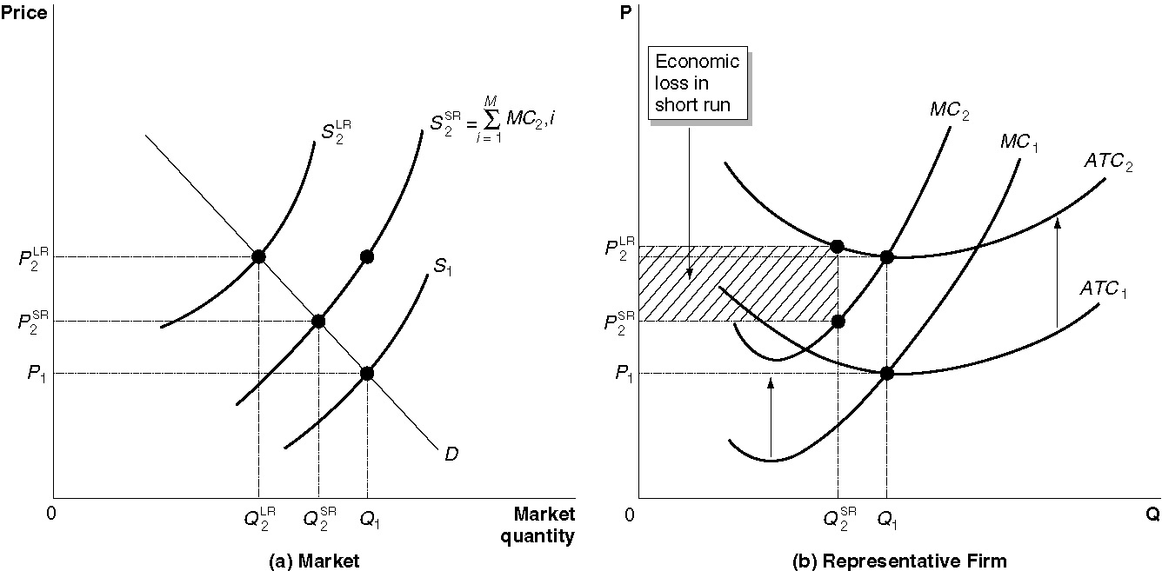
Answers to Review Questions

1. Perfectly competitive markets are marked by 1) many buyers and sellers, 2) all firms selling identical products, and 3) no barriers to firms entering the market.

2. A price taker is unable to affect the market price, but a price maker can. Most consumers are price takers for most goods – for example, you can’t go to the grocery store and negotiate for a price different than the one marked on the shelf. Because a firm in a perfectly competitive market is very small relative to the market, and because it is selling exactly the same product as every other firm, it can sell as much as it wants without having to lower its price. If the firm raises its price, the firm will sell nothing.

3. The graph will look like Figure 11-2 on page 357.

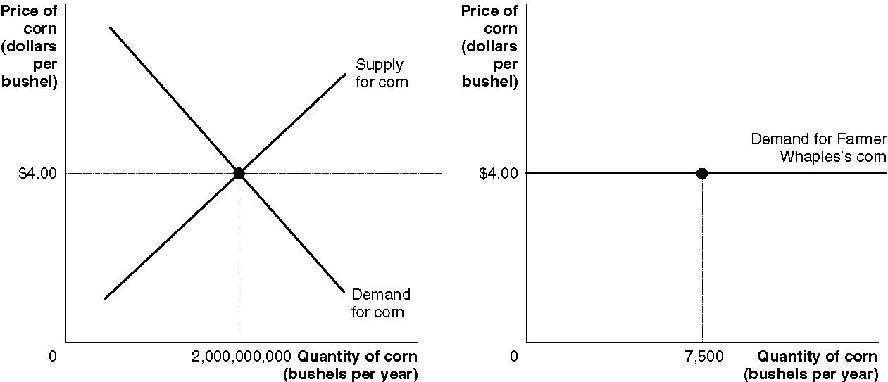

4. The graph will look like the figure in step 6 of Solved Problem 11-1 on page 363.

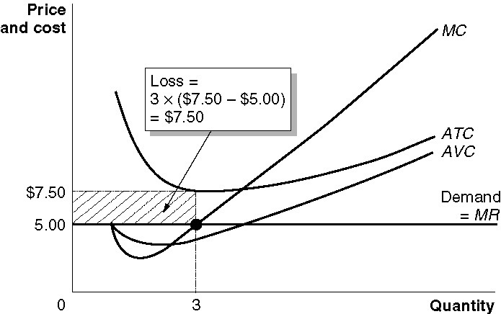

5. In a perfectly competitive market, MR = P, making these two conditions equivalent.

6. In the short run, a firm will shut down if the price falls below the minimum point on its average variable cost curve. In the long run, a firm will shut down (exit) if the price is below the minimum point on its average total cost curve. In the short run, the firm is willing to accept losses, because it cannot do anything about its fixed costs – and must pay them whether or not it is producing anything. In the long run, however, the firm can exit the industry if it expects continued losses.

7. Economic profits lead firms to enter an industry; economic losses lead firms to exit an industry.

8. A firm earning zero economic profit would continue to produce, even in the long run, because it is earning as much as it would earn elsewhere – it is earning the going rate of return on its investment.

9. The long-run supply curve in a perfectly competitive market will be a horizontal line if it is a constant cost industry – that is, if the typical firm’s average cost curves are unchanged as the industry expands or contracts. If it is an increasing-cost industry, the long-run supply curve will slope upward; if it is a decreasing-cost industry, the long-run supply curve will slope downward. Figure 11-10 (b) shows how a perfectly competitive constant cost industry adjusts to a permanent decrease in demand.

10. Allocative efficiency is the state of the economy in which production reflects consumer preferences; in particular, every good or service is produced up to the point where the last unit provides a marginal benefit to consumers equal to the marginal cost of producing it. Productive efficiency is the situation in which a good or service is produced at the lowest possible average cost. Productive efficiency deals with how a good is produced, while allocative efficiency deals with producing the goods and services that consumers value most.

Answers to End of Chapter Problems and Applications

1. a. is perfectly competitive; b., c., and d. are not perfectly competitive because there are not enough sellers, products are not identical, or there are barriers to new firms entering.

2. The remark confuses the market demand for wheat with the demand facing one farmer selling wheat. Remember that the units used in drawing the market demand curve are much greater than the units used in drawing the individual farmer’s demand curve.

3. To find economic profit, we need to subtract the opportunity cost of her time and the funds she is using from her accounting profit: $80,000 – $65,000 – $5,000 = $10,000.

4. No, because the opportunity cost to your sister of using the copiers is $1,500, which is equal to your cost of renting them.

5a. Frances will charge the market price of $1.80. Her profit maximizing output level is 6 earrings. She should expand output up to the point where MR = MC, but remember that in a competitive market MR = P. The 6th earring’s marginal cost is $1.60 – less than the marginal revenue it generates, but the 7th earring’s marginal cost is $1.90 – slightly more than the marginal revenue from selling it. Profit rises from making the 6th, but it falls from making the 7th. Her profit = revenue – total cost = (price x quantity) – total cost = ($1.80 x 6) - $6.80 = $4.

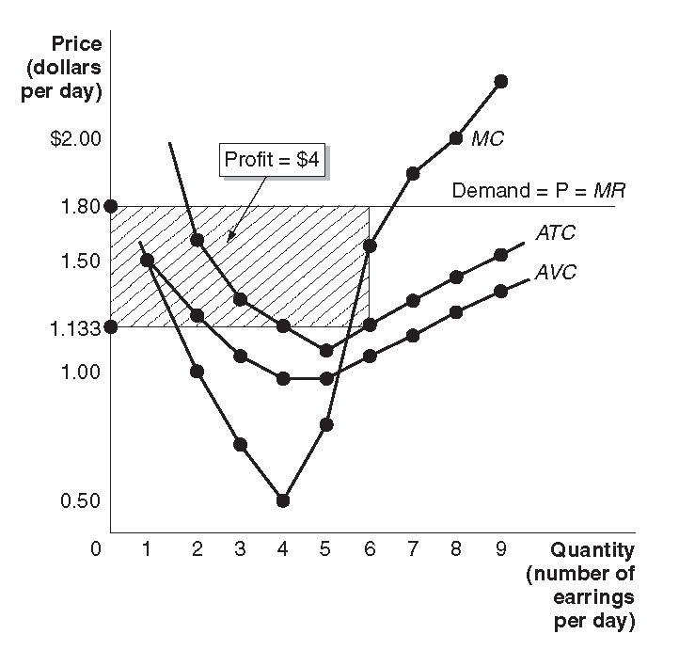

Output per day | Total Costs | AFC | AVC | ATC | MC
0 | $1.00 | — | — | — | —
1 | 2.50 | $1.00 | $1.50 | $2.50 | $1.50
2 | 3.50 | 0.50 | 1.25 | 1.75 | 1.00
3 | 4.20 | 0.33 | 1.066 | 1.40 | 0.70
4 | 4.50 | 0.25 | 0.875 | 1.125 | 0.30
5 | 5.20 | 0.20 | 0.84 | 1.04 | 0.70
6 | 6.80 | 0.167 | 0.967 | 1.133 | 1.60
7 | 8.70 | 0.143 | 1.10 | 1.243 | 1.90
8 | 10.70 | 0.125 | 1.213 | 1.338 | 2.00
9 | 13.00 | 0.111 | 1.333 | 1.444 | 2.30

b. Frances will charge $1 and produce 5 earrings. Her loss will be (5 x $1) - $5.20 = $0.20, which is smaller than the loss of $1 if she shuts down.

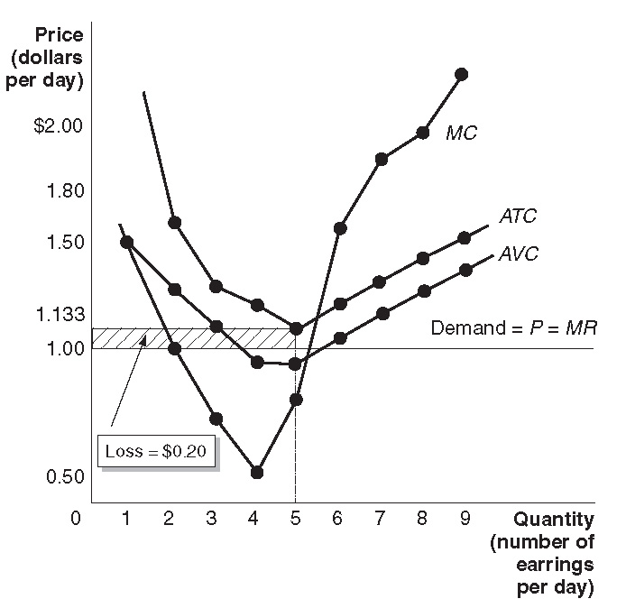

c. If the price falls to $0.25, she will shut down – since price is less than the minimum point on her AVC curve. Her loss will be her fixed cost of $1.

6. The company is a price taker because it is in a very competitive industry. The company should charge the market price.

7. a.
Output per week | Total Costs | AFC | AVC | ATC | MC
0 | $100 | — | — | — | —
1 | 150 | $100.00 | $50.00 | $150.00 | $50.00
2 | 175 | 50.00 | 37.50 | 87.50 | 25.00
3 | 190 | 33.33 | 30.00 | 63.33 | 15.00
4 | 210 | 25.00 | 27.50 | 52.50 | 20.00
5 | 240 | 20.00 | 28.00 | 48.00 | 30.00
6 | 280 | 16.67 | 30.00 | 46.67 | 40.00
7 | 330 | 14.29 | 32.86 | 47.15 | 50.00
8 | 390 | 12.50 | 36.25 | 48.75 | 60.00
9 | 460 | 11.11 | 40.00 | 51.10 | 70.00
10 | 540 | 10.00 | 44.00 | 54.00 | 80.00

b. Harry should produce 7 lamps, and he will make profit = $350 – $330 = $20.
c. No, Harry should only shut down if the price falls below the minimum point on his AVC curve, which is $27.50.
8.
a. Total cost = A + B + C
b. Total revenue = A + B
c. Variable cost = A
d. Loss = C
The firm will continue to produce in the short run because it has revenue greater than its variable costs.

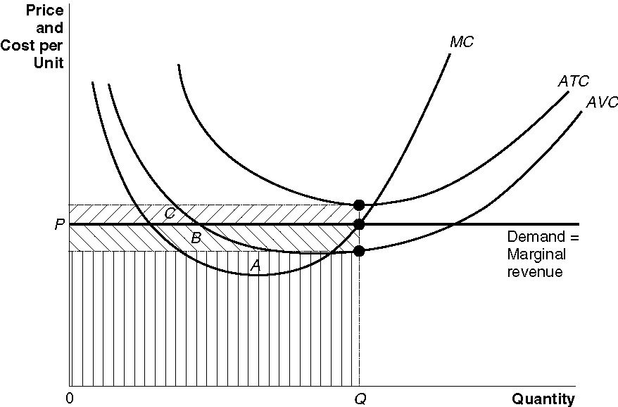

9. The table gives his average variable cost. $2.50 per basketball is below Andy’s minimum average variable cost, so he will shut down.

Output Per Day (Q) | Total Cost (TC) | Fixed Cost (FC) | Variable Cost (VC) | Average Total Cost (ATC) | Average Variable Cost (ATC) | Marginal Cost (MC)
0 | $ 10.00 | $ 10.00 | $ 0.00 | - | - | -
1 | 15.00 | 10.00 | 5.00 | $ 15.00 | $ 5.00 | $ 5.00
2 | 17.50 | 10.00 | 7.50 | 8.75 | 3.75 | 2.50
3 | 22.50 | 10.00 | 12.50 | 7.50 | 4.17 | 5.00
4 | 30.00 | 10.00 | 20.00 | 7.50 | 5.00 | 7.50
5 | 40.00 | 10.00 | 30.00 | 8.00 | 6.00 | 10.00
6 | 52.50 | 10.00 | 42.50 | 8.75 | 7.08 | 12.50
7 | 67.50 | 10.00 | 57.50 | 9.64 | 8.21 | 15.00
8 | 85.00 | 10.00 | 75.00 | 10.63 | 9.38 | 17.50
9 | 105.00 | 10.00 | 95.00 | 11.67 | 10.56 | 20.00

10. Disagree – no matter how great demand may be, if there are no barriers to firms entering the industry, profits will be competed away in the long run.

11. When the market price falls to $7, she must match it or her sales will fall to zero.

12. This argument is incorrect. In order to maximize profit, the firm should produce up to the point where marginal revenue equals marginal cost. By producing only Q₁, the firm will miss out on all the profits to be made on units between Q₁ and Q₂.

13. Total profit can rise, even if profit per passenger falls, if the total number of passengers rises. The graph is drawn so that price stays the same, while the firm increases the scale of its operations. The average total cost per passenger is now slightly higher, shrinking profit per passenger – but the quantity has risen significantly, so total profits have risen, from (P – ATC₁) x Q₁ to (P – ATC₂) x Q_{2.} . (British Airlines’ price may have risen also, which would have increased its total profits, but the graph doesn’t show this.)

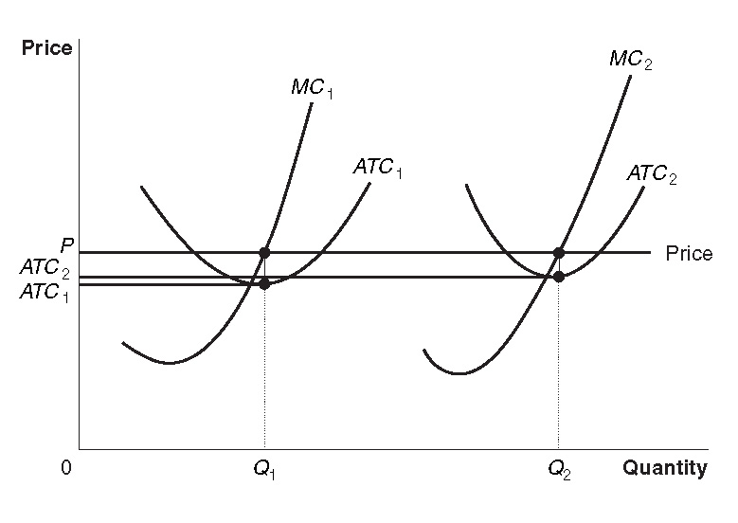

14. As shown in the figure, the cost curves have shifted upward so that the price of fertilizer is now below the minimum point on the average variable cost curve.

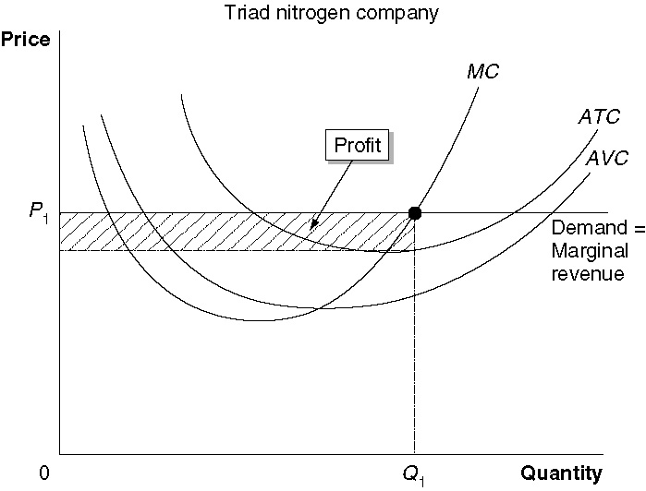
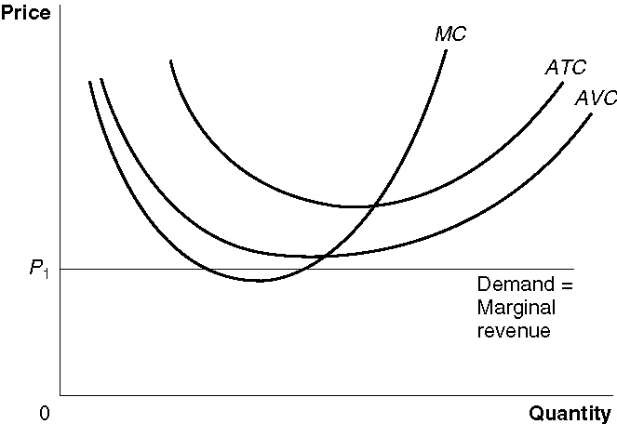

15. Yes, because you are covering your variable costs.

16. Airlines, like other businesses, will continue to operate so long as they can cover their variable costs. The statement that “revenues will cover a large part of their cost,” refers to total costs. If revenues covered only a large part, but not all, of the firm’s variable costs, it would shut down. These revenues seem to cover all of the variable costs plus some of the fixed costs.

17. Club Med must have decided that the loss from temporarily shutting down was smaller than the loss from continuing to operate. This indicates that the revenues from operating were insufficient to cover their variable costs.

18. In perfectly competitive markets, firms may temporarily earn greater profits from a reduction in costs. However, in the long run, lower costs result in lower prices, which benefit consumers, but not higher profits.

19. As long as it is possible for firms to enter the industry, competition will force profits down to the level of a normal rate of return. In the long run, even without a law being passed, prices will be exactly equal to the average total cost of production.

20. The remark is incorrect because the student has confused accounting profit and economic profit. Zero economic profit includes a normal rate of return on the investment of the owners of the firm.

21. The freeze in California shifts the supply curve of lettuce from S₁ to S₂. The decline in dining out shifts the demand curve for lettuce from D₁ to D₂. The result is that the equilibrium price rises from $1.50 to $3.00 per head. The economic profits to be earned growing lettuce at $3.00 causes an increase in supply from S₂ to S₃, which restores the equilibrium price to $1.50 per head. The market price reporter was confident prices would drop to their usual levels because he knew that in a perfectly competitive market like lettuce, whenever prices rose above their usual levels, the higher profits to be earned result in an increase in supply.

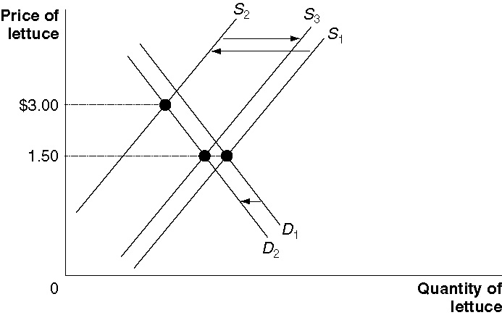

22. The increase in the demand for laptop computers causes the demand curve to shift from D₁ to D₂, temporarily driving the price up to P₃. As the production of laptops increases, more orders are placed for laptop displays. As production of laptop displays increases, their cost and price falls because of economies of scale. With increased demand and lower costs, the firms that assemble laptops can make economic profits at P₃. The result is that new firms enter the industry, the industry supply curve shifts from S₁ to S₂, driving down the price to P₂ and eliminating economic profits. Because the price of laptop computers declines as output increases, the long-run supply curve is downward sloping. This is a decreasing-cost industry.

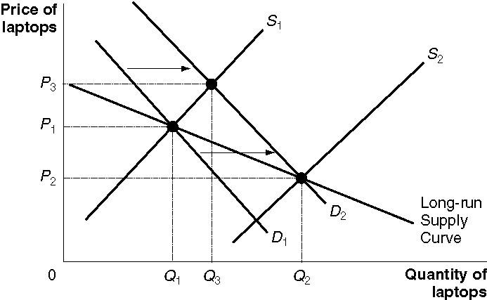
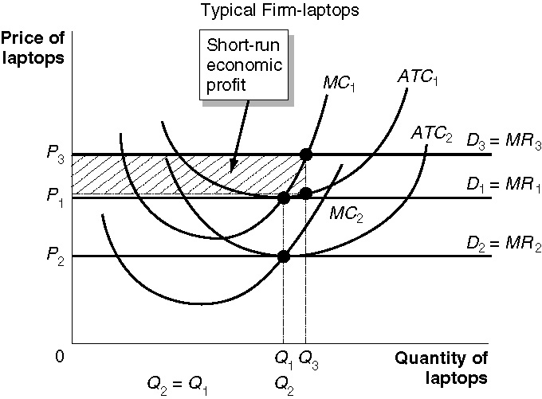

23. Because they could make economic profits for a few years.

